**Farewell AI Project Documentation**

**1. Project Overview**

**1.1 Project Title**

Farewell AI Project: Career Guidance Chatbot

**1.2 Project Goal**

To design and implement a simple, AI-based chatbot that assists users in exploring suitable career options.

**1.3 Project Objectives**

* Develop a user-friendly chatbot that asks a series of questions related to a user's interests, skills, and favorite subjects.
* Implement a clear AI logic, such as a decision tree or natural language matching, to process user input.
* Provide tailored career suggestions based on the user's responses.
* The final project should be a proof-of-concept that demonstrates an understanding of basic AI principles.

**1.4 Assignment Roles**

* **Build Chatbot:** Duduzile Mgcina and Kutlwano Kaupe
* **Documentation:** Thandazile Ncamiso
* **Testing and Quality Assurance Engineer:** Sukoluhle Ndlovu
* **Presentation and Demo:** Nombulelo Olifant

**1.5 Scope**

**In-Scope**

* A conversational chatbot interface.
* A predefined set of questions for the user.
* A logic tree to map user responses to career suggestions.
* A curated list of career options and their descriptions.
* Implementation using one of the specified platforms (Python, Google Colab, Dialogflow, or PowerPoint mockup).

**1.6 User Profile Questions for Career Guidance Chatbot**

1 What are your top 3 favorite subjects in school or college?

*(Helps match with subject-based career fields, like STEM, arts, etc.)*

2. Which of the following areas interest you the most? (Choose all that apply)

* Technology
* Business
* Healthcare
* Arts & Design
* Law & Politics
* Education
* Science & Research
* Environment & Nature
* Social Work

3. What kind of tasks do you enjoy doing most?

* Solving technical problems
* Helping people
* Designing or creating things
* Working with numbers and data
* Speaking or presenting
* Managing projects or people
* Writing and content creation
* Experimenting and exploring ideas

4. What is your highest level of education (or current level)?

* High school
* Diploma
* Undergraduate degree
* Postgraduate degree
* Self-taught / Online courses

5. How would you describe your personality? (Pick the best fit)

* Analytical and logical
* Creative and expressive
* Practical and hands-on
* Empathetic and caring
* Organised and detail-oriented
* Energetic and outgoing

6. Do you prefer working…

* Alone
* In a team
* Both

7. What kind of work environment do you prefer?

* Office-based
* Remote / Digital
* Outdoors / Fieldwork
* Laboratory / Research
* Creative Studio
* Healthcare / Hospital

8. Which of the following skills do you feel confident in? (Select up to 5)

* Programming
* Drawing / Design
* Public speaking
* Leadership
* Research
* Writing
* Data analysis
* Emotional intelligence
* Mathematics
* Marketing

9. Do you have any specific career goals or dream jobs in mind? *(Optional, open-ended)*

10. Would you prefer a career that is…

* High-paying
* Fulfilling / Passion-driven
* Secure and stable
* High-growth / Future-ready
* Flexible

**2.4 Logic/Design**

The chatbot will use a **decision tree** to guide the user to a career path.

* **Step 1:** Ask a broad question to categorize user interests (e.g., "Do you prefer working with people, data, or creative ideas?").
* **Step 2:** Based on the initial answer, ask a more specific question to narrow down the focus (e.g., "If you like working with people, do you prefer helping others, teaching, or selling?").
* **Step 3:** A final question or two will lead to a specific career cluster.
* **Step 4:** The chatbot will present a tailored suggestion from that cluster.

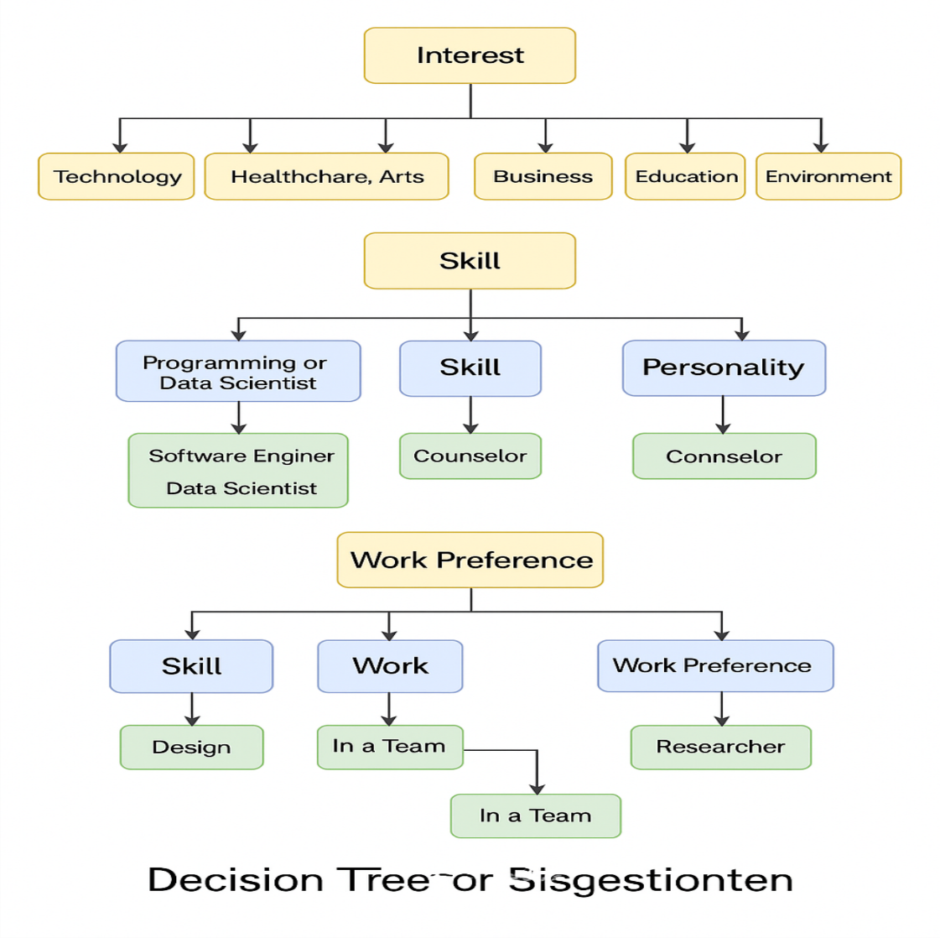**3.**

**Technical Documentation**

**3.1 Setup & Installation Guide**

* **For Python:** List required libraries and provide a link to the notebook.

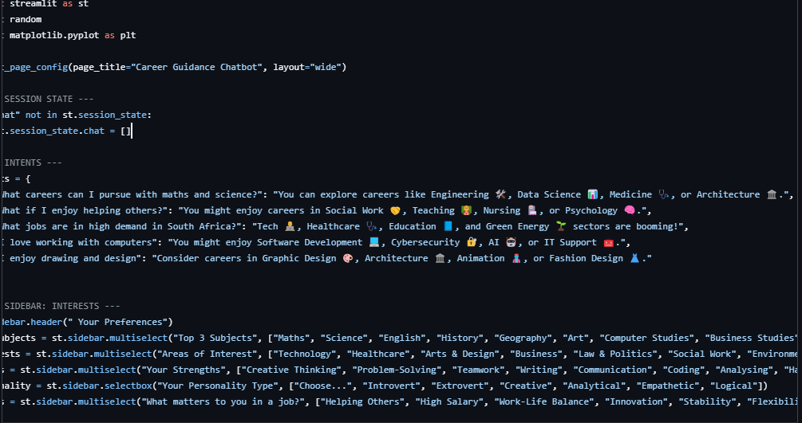

* **For Streamlit:**

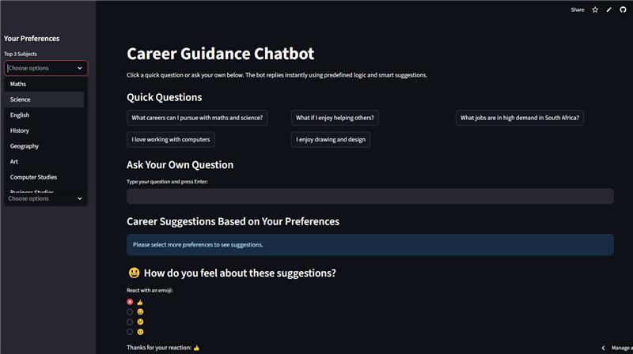

**4. User Documentation**

**4.1 User Manual**

1. **Start:** Begin by interacting with the chatbot's welcome message.
2. **Respond:** Answer the chatbot's questions by typing a short response or selecting from a multiple-choice list.
3. **Receive:** The chatbot will provide a career suggestion based on your answers.

**4.2 Troubleshooting**

* If the chatbot doesn't understand you, try re-phrasing your answer.
* If the suggestions are not relevant, you can restart the conversation to explore a different path.

**4.3 Test Case:**

**Test Case for Career Guidance Chatbot (Streamlit and OpenAI)**

**Test Case ID: TC_CHATBOT_001**

**Career Guidance Questions**

1. What are your top 3 favorite subjects? *(Sidebar: fav_subjects)*
2. Which areas interest you the most? (Sidebar: interests)
3. What are your strengths/skills? (Sidebar: skills)
4. What is your personality type? (Sidebar: personality)
5. What is your personality type? (Sidebar: personality)

**Test Case**

Below is a detailed test case for validating the chatbot's recommendation flow. 

|  |  |  |  |  |
| --- | --- | --- | --- | --- |
| **Step** | **User Input** | **Expected Bot Behavior** | **Expected Career Suggestion** | **Pass/Fail** |
| **1** | User visits app | UI loads with sidebar for preferences and input area | Sidebar visible, chat input enabled | **Pass** |
| **2** | Selects: Maths, Science, Computer Studies | Bot reads STEM-related subjects | Adds Data Analyst, Software Engineer | **Pass** |
| **3** | Selects: Technology, Science & Research | Bot identifies interest in tech and R&D | Adds AI Engineer, Data Scientist | **Pass** |
| **4** | Selects: Problem-Solving, Coding | Bot recognizes technical strengths | Confirms match with software, AI, or data roles | **Pass** |
| **5** | Selects: Analytical | Bot matches to logic-based careers | Adds Data Scientist or Analyst | **Pass** |
| **6** | Selects: Helping Others, Innovation | Bot detects empathy + innovation values | Suggests Social Worker + AI roles | **Pass** |
| **7** | Inputs “What if I enjoy helping others?” in chat | Bot detects predefined intent | Suggests Social Work, Nursing, Teaching | **Pass** |
| **8** | Types: “I love computers and math” | Bot uses keyword-based logic | Suggests software or data-focused roles | **Pass** |
| **9** | No input provided | Bot responds with prompt to explore sidebar | “Select preferences to get suggestions” | **Pass** |
| **10** | Views Skills Chart | Chart loads with random percentages | Bar graph appears based on selected skills | **Pass** |

**Expected Results**

* Bot processes sidebar inputs and chat queries correctly.
* Responses are consistent with predefined logic.
* Multiple relevant career suggestions are displayed using st.success().
* Skills chart appears if any skills are selected.
* Emoji feedback is collected after career suggestions.

**Fail Conditions**

|  |  |
| --- | --- |
| **Failure Scenario** | **Description** |
| 1. Sidebar inputs not read properly | No career suggestions displayed despite valid input |
| 1. Button click or text input unresponsive | Chat does not append user/bot messages |
| 1. Inappropriate suggestions | For example, suggesting art careers for STEM users |

**4.4 Link for the Chatbot:**

https://career-guidance-chatbot-n5cznrsy8jti28ymgwbemr.streamlit.app/